15.20: a) Using Eq.(15.25),
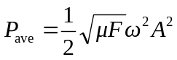
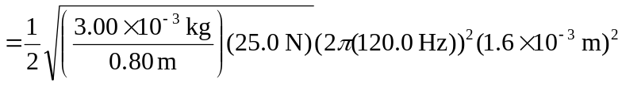
= 0.223 W,

or 0.22 W to two figures. b) Halving the amplitude quarters the average power, to 0.056 W.

